Benefit Ride for JESSICA LEE

Saturday, April 14, 2012

Registration 8:30-9:30 Kickstands Up @ 10 a.m.

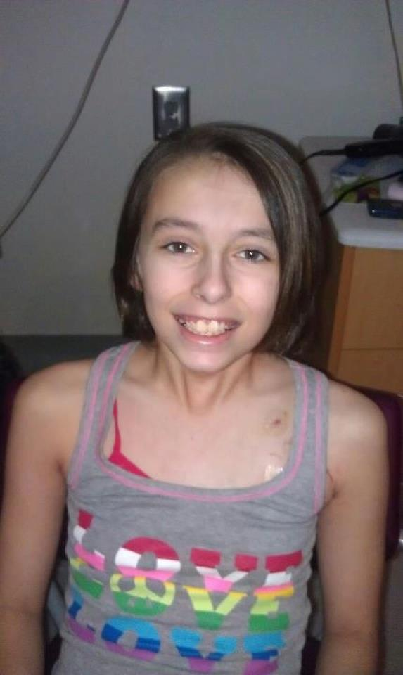

She is 10 years old. She is very active in her church and sports. She plays softball and basketball. She loves Alabama football. Her leukemia came on quick. She has AML (which is more common in adults). She was in the hospital within 2 weeks of having symptoms. She was feeling tired all the time and she slowly started looking pale. On Feb 14th she played in a basketball game and she told the coach to take her out cause she was tired and her chest started hurting. Shelley took her to the pediatrician office and they checked her hemoglobin. Her level was at a 5 so they sent her to the hospital that night for blood work. The next day (15th) they sent her to Scottish Rite. From there they sent her to Egleston b/c they specialize more in the type that Jessica had. She started her first round of Chemo on the 17th and it lasted 10 days. She will be there for another couple of weeks then she will get to come home for about 2 weeks. She will then go back to the hospital and start another round of chemo. She will be in the hospital for about another month.

The ride will begin at Bahama Tan on South Park Street, go thru Buchanan turning right on Hwy 120, then right on Hwy 101 at Roses Store, right on Hwy 61 and ending at Slammerz Cycle Haven on Bankhead Hwy.

The ride cost is $20 plus $5 for a passenger this cost includes ride, food, fun & a ticket which gives you a chance to win one of many giveaways!!

Shirts & bracelets will be available as well…short sleeve $16, long sleeve $22, hoodies $24 and bracelets $3 all can be pre ordered in advance at Bahama Tan (928 South Park S., Suite L, Carrollton, GA), Slammerz Cycle Haven (1202 Bankhead Hwy., Carrollton, GA) or Allstate – Alisha Windom Agency (1665 N Hwy 27., Carrollton, GA)

For more information contact Carri @ Bahama Tan 678-977-8239 or Amber @ Slammerz Cycle Haven 770-834-6999