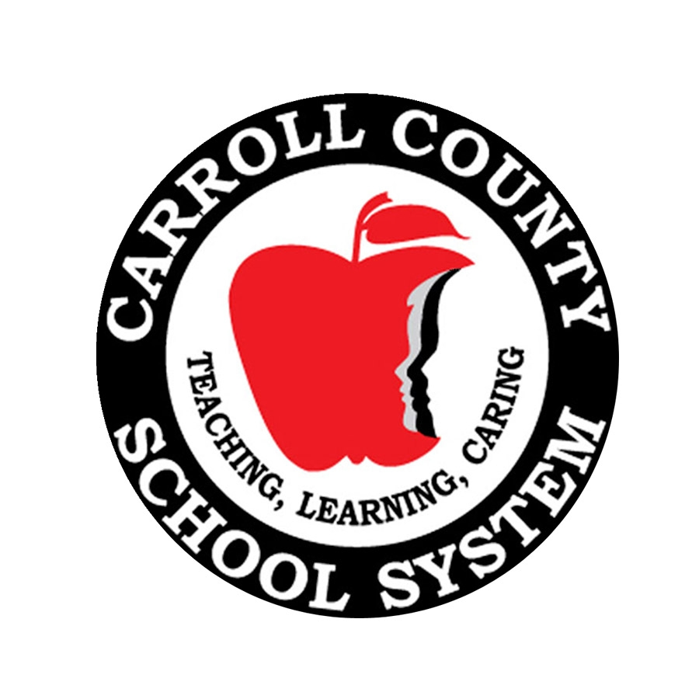

Carroll County Schools
Open House Schedule

2013-2014

School: | Date: | Time: P.M.
Bay Springs Middle | August 6th | 5:30 – 7:30 p.m.  6th & New Students–Gym-5:00  7th & 8th – Cafeteria – 5:30
Bowdon Elementary | ^{August 6th} | 3:00 – 5:00 p.m.
Bowdon Middle | August 6th | 4:00 – 6:00 p.m.
Bowdon High | August 6th | 5:00 – 7:00 p.m.
Central Elementary | August 7th | 4:00 – 6:00 p.m.
Central Middle | August 6th  August 7th | 7th & 8th 5:00-7:00 p.m.  6th 5:00 – 7:00 p.m.
Central High | August 6th | 6:00 – 7:30 p.m.
Glanton-Hindsman Elementary | August 7th | 4:00 – 6:00 p.m.
Ithica Elementary | August 6th | 4:30 – 6:30 p.m.
Mt. Zion Elementary | August 6th | 4:00 – 6:00 p.m.
Mt. Zion Middle | August 6th | 5:00 – 6:45 p.m.
Mt. Zion High | August 6th | 12th 3:00 – 4:00 pm  9th-11th 4:00 – 5:00 pm
Providence Elementary | August 6th | 4:00 – 6:00 p.m.
Roopville Elementary | August 6th | 4:00 – 6:00 p.m.
Sand Hill Elementary | August 7th | 5:00 – 7:00 p.m.
Sharp Creek Elementary | August 6th | 4:00 – 6:00 p.m.
Temple Elementary | August 6th | 5:00 – 7:00 p.m.
Temple Middle | August 1st  August 6th | 6th 9:00 – 3:00 p.m.  7th & 8th 4:00 – 6:00 p.m.
Temple High | August 6th | 4:30 – 6:30 p.m.
Villa Rica Elementary | August 6th | 4:00 – 6:00 p.m.
Villa Rica Middle | August 6th | 6:00 – 7:30 p.m.  A – K 6:00 p.m.  L – Z 6:45 p.m.
Villa Rica High | August 6th | 5:00 – 7:00 p.m.
Whitesburg Elementary | August 6th | 4:00 – 6:00 p.m.

Revised July 22, 2013

